SELF CARE:
ESSENTIAL PRACTISE FOR US ALL

Introducing the Content:
This session is about reminding yourself why self care is so important and re-iterating the various aspects of it. This is beyond the more popularised idea of bubble baths and herbal teas, which are totally valid and brilliant but not the be-all and end-all of self care. We hear of self care all the time, but it can be helpful to revisit what it really means and why we do it.
We know that more than ever, non-mental health and wellbeing trained people in Colleges and in general life are having mental health conversations.
With higher incidences of blended learning and working from home, it is felt that we have less time to have supportive conversations, which contribute to our sense of wellbeing. We think that it could be helpful to reflect on what we can do to look after ourselves and why.

Mental Health and Wellbeing defined:
There are many definitions of mental health and wellbeing. At SAMH, we use the World Health Organisations definition. This demonstrates a holistic view on mental health and wellbeing and is very inclusive of everyone (not merely absence of disease or infirmity).
This definition reduces stigma and can be viewed on a personal level, i.e. my own potential, my own everyday stresses:
“A state of complete physical, mental and social wellbeing and not merely the absence of disease or infirmity
A state of wellbeing in which every individual:
- Realises their own potential
- Can cope with the normal stresses of life
- Can work productively and fruitfully
- Is able to make a contribution to their community
The overall message is a relationship between mental health and our wellbeing, and we all have mental health, which can and does fluctuate throughout life events. We can think more about what we do to ‘keep ourselves well’ and to be resilient to the highs and lows of life, rather than a direct focus on our mind or diagnoses.
- 1 in 4 people will experience a mental health problem in any given year
- 1 in 15 people will experience depression in Scotland
- 1 in 17 people will experience anxiety in Scotland
- 1 in 100 people will experience bipolar
- At least 1 in 6 employees at work experience depression, anxiety or another mental health condition at any one time
- Nearly half (45%) of Scottish workers think people wouldn’t speak about their mental health for fear of discrimination from their colleagues
Further reading:
For more context, it is helpful to know about the Scottish Government Mental Health Strategy 2017-2027: www.gov.scot/publications/mental-health-strategy-2017-2027

Assessing the Personal Impact of Supporting Someone Else With Mental Wellbeing Challenges:
Thinking about helping others and the kind of rewards and challenges you might get, we can begin to understand and plan how to keep ourselves well.

Positives:
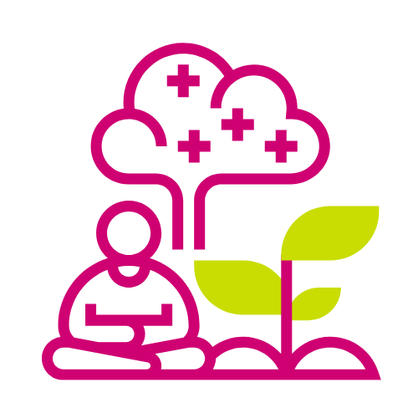
- Being there to witness and support others’ personal achievement and rewards
- Contributing to the positive mental health and wellbeing of the next generation through modelling supportive behaviours
- Creating positive destinations and strengthening society
- Empowering others to keep themselves safe (within your own boundaries)
- Making a difference matters

Negatives:
- Being made aware of challenges but knowing you’re unable to ‘fix’ all problems
- It can be difficult to ‘switch off’ after supporting someone
- Experiencing vicarious trauma
- Feeling that you have not succeeded if the person doesn’t feel better
- Risk of over-dependency of person on you

Looking Deeper at Trauma
Vicarious trauma
Vicarious trauma describes the emotional remnants that people may experience in their own lives from supporting vulnerable people and hearing their trauma stories.
By hearing challenging stories from others, we can witness the pain, fear, and terror that trauma survivors have endured. Essentially this describes second-hand trauma.
Please note if you find yourself:
- Experiencing lingering feelings of anger, rage and sadness about another persons victimisation after hearing of their trauma
- Becoming overly involved emotionally with the person
- Experiencing bystander guilt, shame, feelings of self-doubt
- Over identifying with the person
- Difficulty in maintaining boundaries with the person, such as overextending self (trying to do more than is within the role to help them)

If you are experiencing any of these signs, this could indicate that you are suffering from vicarious trauma.
When you begin to recognise the heaviness that you might be taking on helping others and how it could affect you, it becomes ever clearer why self care is utterly essential in the kind of work you do.
Burnout
Burnout is a separate but co-occurring concept that can be a negative side effect of supporting vulnerable people or in any continuously stressful setting.
This is a state of emotional, physical, and mental exhaustion caused by excessive and prolonged stress. It occurs when you feel overwhelmed, emotionally drained, and unable to meet constant demands.
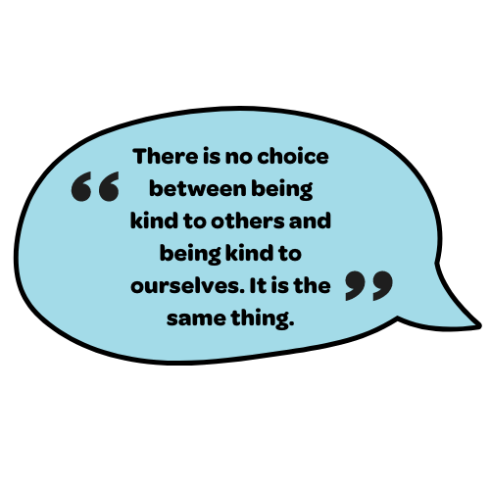
Burnout usually occurs when there’s a cumulative impact of two or three of the sources of stress building up and not being addressed with MH&WB tools over some time.
Perhaps by reflecting on these, it highlights why we can be emotionally impacted by individual seemingly lower impact occurrences when, put into context, can be quite detrimental to us.

- Pierro Ferruci, The Power of Kindness

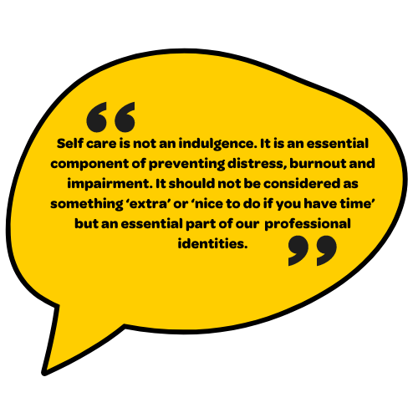

- Barnett, Baker et al 2007

Some Activities to Get Started Planning Your Self Care
So we’ve identified lots of the challenges, and we agree that addressing them and prioritising ourselves is essential, but now where do we start?
My Wellbeing Diary Activity
An activity to remind yourself how essential self care is:
- Write down 10-15 things you do every morning before work.
- Score out 5 of those things
- Reflect on how this would impact your day
- Reflect on how this would impact your wellbeing.

Self Care Check-In
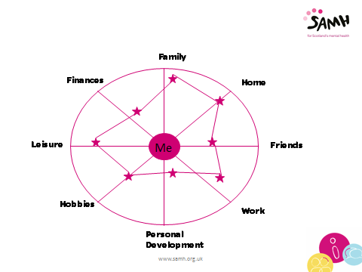
An activity to help you decide on an area of focus:
- Draw a circle with five lines through it.
- Each spoke represents an important area of your life with you at the centre, the hub that holds everything together. Think about what you would put at the end of each spoke.
- Now think about each of these areas in turn and mark on the spoke where you feel you are in relation to your heading.
- If you feel that you have everything well controlled and can make no difference to that area, mark yourself right out at the end of the spoke.
- If there are issues, then bring your mark nearer to the hub. The nearer to the hub, the more attention you require to pay to this area.
- Once you have done this for each spoke, join the marks up.

Ideally, you want to have a rounded circle in the wheel. This would indicate that you have the main areas in your life balanced and controlled.
Look at your wheel and decide which areas require attention due to the wheel's imbalance; this will help you focus on where to improve. The lowest area could be a good place to start to prioritise and give you a focus for your self care.
For example, the person in the above diagram wheel has a fantastic balance in their ‘Family’ section – maybe intuitively, their first place to turn for self care might be spending time with family members. However, if their fulfilment in the area of ‘Personal Development’ is relatively low, this could be a more productive place to focus.

Make Sure You’re Covering the Fundamentals
Sometimes when we are looking to change our mental health and wellbeing as part of self care, we can look to more ‘literal’ sources of mental health support, such as Counselling. However, smaller changes to our day to day routine can make such a foundational change in our lives from which growth can come.
5 Ways to Better Mental Health
There are lots of things we can do every day to support our wellbeing. The New Economic Foundation and SAMH suggest the following five ways to better wellbeing.

Connect Staying in touch with loved ones can make us feel happier and more secure, and often just having a chat can help lift our mood.
- Put five minutes aside to ask someone how they are
- Arrange to meet up with a friend that you haven’t seen in a while
- Join a local group or club and meet new people in your community

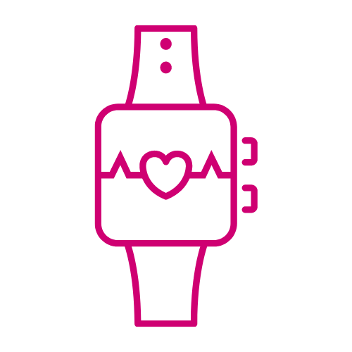
Be Active Being active isn’t just good for our physical health; it’s also proven to positively affect our mental health and wellbeing.
- Go for a short walk at lunchtime
- Discover a physical activity you enjoy and one that suits you
- Try the NHS’s Couch to 5K programme
- Check out jogscotland’s group finder for your nearest jogging group

Take Notice Whether you’re spending time with friends or taking a moment for yourself, try to stop to take notice and be aware of the present.
- Set aside time to practise mindfulness or take up yoga
- Take notice of how your friends or colleagues are feeling
- Spend time outdoors, enjoy the fresh air and notice what’s around you

Learn Learning enhances your self-esteem and confidence and can be a great way to meet new people.
- Sign up for a class and learn something new
- Rediscover an old interest, such as cooking or gardening
- Take on a new challenge to make or fix something

Give Giving can be very rewarding – in fact, those who report a greater interest in helping others are more likely to rate themselves as happy.
- Volunteer your time for a cause you are passionate about
- Spend time with someone who you know has been having a difficult time

Looking at Habits, Knowing Vs Doing
We know that drinking coffee mimics the effects of anxiety, but knowing something is different from putting it into action. Perhaps you know someone who shows daily feelings of anxiety such as heart racing, nervousness or restlessness. Do they make honest efforts to minimise their caffeine?
Consider other areas which do contribute to overall wellbeing. Do you need to consciously adjust any habits in the areas of sleep, diet, physical activity?
It’s Okay Not to Be Okay
Try your best to take time to validate and notice your feelings. Know that it can be helpful and productive to fully feel your feelings and work through them. Sometimes we can panic if we think something negative and go straight into ‘fixing mode’, but this can distract us from what we really wish we could do or would like to change.
Remember that within reason, it’s valid to be angry at things that are anger inducing. It’s valid to be upset about upsetting things. It’s valid to be worried about worrying situations. Humans are meant to feel a range of emotions. When there is such a focus on staying positive, sometimes we can feel pressure not to feel these rational and understandable emotions. When these feelings happen, focus on looking after yourself and seeking further professional help if they go on for a while or become overwhelming.
Grow Your Mindset: Our Brains are Malleable
Many people live with ‘negative self-talk’, which can significantly impact us. Our inner dialogue can be limiting our ability to believe in our self and our own abilities. We can blame ourselves, filter out the positives, amplify the negatives, and see things in ‘black and whites’.
If you notice reoccurring thoughts such as, for example:
- You usually get up early, but this week your mood has dipped due to the weather, and you find yourself telling yourself, ‘I’m sooo lazy. Why do I sleep so much?’
Think about how you can realistically and gently correct these types of thoughts, as they aren’t true in the grand scheme of things:
- Realistic is important. If you are someone who believes you’re ‘soooo lazy’ it might be challenging to turn around overnight and think ‘, I am so energetic and the most dedicated person ever!’ but could you try thinking ‘I’m allowed to make choices that cater to my needs at this moment in time, and I am tired.’
While it can feel cheesy for some of us to correct our thoughts in this way, doing this and practising self affirmations can significantly affect the way we automatically jump to negative thinking. This takes practise, dedication and patience.

Make a Wellbeing Plan
Developing a ‘Wellbeing Plan’ is a proven method to help support your wellness. During this process, we reflect on the causes of positive and negative mental health and take ownership of practical steps to address these triggers.
There are a few different methods of making a wellbeing plan, including pupil/student friendly frameworks or frameworks specifically for the workplace. Many wellbeing plans are intended to be shared with others, such as a manager or a supporter, to aid their understanding of your specific experiences.
- The original version of this practise comes from Mary Copeland – who wrote the tried and tested Wellness Recovery Action Plan (WRAP). Read more about this here: mentalhealthrecovery.com/wrap-is/
- The Charlie Waller Memorial Trust have also written a student wellbeing plan template for those aged 16+: charliewaller.org/resources/wellbeing-action-plan-aged-16
- Mind charity have made a specific guide for employees interested in a plan: mind.org.uk/media-a/5760/mind-guide-for-employees-wellness-action-plans_final.pdf

Some questions for you to consider around the workplace/college and your own plan:
            - Am I mentally healthy at work/college? If so, what keeps me that way (colleagues, management, personal skills, job role)? If not, why and what needs to change, how do you change it, and what support do I need?

            - Do I take personal responsibility for my well being at work college? Do I take a lunch break away from my desk? Do I leave on time at night? Do I take my work home with me? Do I leave my work phone at work? Do I check emails at home? Does my manager know if I’m struggling? (They’re not necessarily mind readers). Do I let management/colleagues know (in a productive way) if my workload has become too much? If I don’t do these things, what support do I need to start?

            - How can my manager/lecturer support me to stay mentally healthy at work/college? (Flexi time? Regular 121 meetings? Open dialogue regarding workload? Clear and consistent expectations and behaviours? Quick response when help/support required? (again, does my manager know these things would help me, what responsibility do I have as an individual to discuss this with them?)

            - What are my work/college related triggers? What could impact my mental health at work/college? (workload? Relationship with colleagues or manager?) Am I aware that triggers in my home life can impact my work, and am I aware that triggers in my work can impact my home life?
            - What are my early warning signs within work.college? (what are the first things that would change in me that may suggest I am becoming unwell? Drop in performance? Time Keeping? Personal Appearance? Attitude? Appearance?

