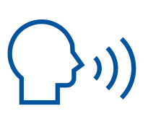

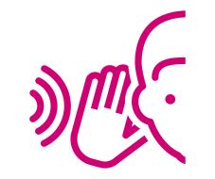
Mental health and listening skills:
more ideas on how to be helpful in conversation
Introducing the Content:
This session is as much about validating the great ways you already support others when having a mental health conversation, than it is sharing new information.
More than ever, non-mental health and wellbeing staff in society are having mental health conversations, particularly including (but not limited to) care staff, nursing staff and more surprising careers like hairdressers or taxi drivers.
As a community, we are also trying to be more supportive to our peers. Many people reach out to look for ways to better support their friends or loved ones. That is why this session is about making mental health conversations with people easier and more effective, whether you are at work or in your community.
We are sharing tips and pointers on how you can protect yourselves better from wellbeing challenges, but also a refresher on language that can be useful to use when talking about these challenging topics.
This is good to remember not only for the sake of learning but for our wellbeing too, so we know how what areas we could look at, and where we are already doing great.

Mental Health and Wellbeing defined:
There are many definitions of mental health and wellbeing, but at the College we like the World Health Organisations as this demonstrates a holistic view on mental health of wellbeing, and is very inclusive of everyone (not merely absence of disease or infirmity).
This definition reduces stigma and can be viewed on a personal level i.e. my own potential, my own normal stresses:
“A state of complete physical, mental and social well-being and not merely the absence of disease or infirmity
A state of well-being in which every individual:
- Realises their own potential
- Can cope with the normal stresses of life
- Can work productively and fruitfully
- Is able to make a contribution to their community”
The overall message is a relationship between mental health and our wellbeing, and we all have mental health which can and does fluctuate throughout life events. We can think more about what we do to ‘keep ourselves well’ and to be resilient to the highs and lows of life, rather than a direct focus on our mind or diagnoses.

The Barriers We Have in Conducting Positive Conversations Around Mental Health
For the Person Who Is Talking About Their Mental Health:
It is helpful to be aware of the context in which someone else is sharing their concerns.
Knowledge of some of the key barriers which might be surrounding our histories, by keeping these in mind, we know what we are working towards trying to mitigate or avoid in our listening practise.
Stigma and discrimination:
In a 2019 study by SeeMe (Scotland’s anti Mental Health stigma and discrimination charity), with over 5000 young people up to the age of 26, fear was shown to be the biggest barrier to young people speaking out about their Mental Health, fear of not being listened to, not being believed or not taken seriously by adults. Also the judgement of peers and family.
www.seemescotland.org/news-and-blogs/thousands-of-young-people-fear-being-judged-rejected-and-isolated-if-they-tell-someone-about-a-mental-health-problem
Lack of Mental Health/emotional literacy:
As Mental Health is not always a structured thing that we are taught about many of us cannot identify the signs and symptoms of poor Mental Health, or do not have the literacy to articulate our emotions, nor do they have the coping skills / self-care knowledge to support ourselves in a meaningful way.
Difficulty identifying support:
While we are often told to speak to our friends and family, many of us find this difficult due to stigma/discrimination, culture or previous bad experiences.
Many people do not feel they have a strong understanding of the support that is external to their immediate circles, such as support groups, professional services and clinical services.

Lack of trusted person:
While not the case for all everyone, some do not feel as though they have a trusting and supportive person in their life and may have had a previous negative experience with adults and their mental health.
Without access to a trusted person, it can be difficult for us to receive the appropriate signposting/guidance.
Research has shown that if a young person is dismissed/has a negative interaction the first time they approach an adult with their problems it can take up to a year to build the courage to talk to someone again.
For the Person who is Listening:
The listener (in this context you as a peer or staff member) needs to be aware of what can get in the way for yourself, stopping us from listening attentively so that such obstacles can be avoided.
We need to be aware of the very human processes and thoughts that we are likely to have, which are valid and understandable but need to be put to one side wherever possible in these contexts. (At least in the ‘listening’ stage of someone sharing their story.)
These include:
1. Thinking of how to respond
2. Trying to think of a solution
3. Asking too many questions
4. Passing judgement on the person or on what is being said
5. Making assumptions about what is being said
6. Being reminded of a situation in your own life and thinking about that.
7. Feeling as though we don’t have enough time, causing impatience
8. Having our own agenda, so leading the conversation to meet our needs
It could be helpful wherever possible to try to fill your mind with one message when listening – “And what else?”
This curiosity about what else the individual has to say can help us to maintain an open mind, it helps our non-verbal communication such as eye contact/eye movement show this sense of care, rather than confusion, alarm, boredom or over-identification.
The skill of listening for understanding is intended to achieve one thing – to enhance your understanding of the perspective of the other person. It is not intended to provide the solution – that comes later and not necessarily from you. So resisting your own solution or evaluation of the problem is not only better in the long run, it is important to avoid having the person sharing simply agree with your version to make you feel right.

Why It Is Important to Have a Conversation
Having a conversation about mental health is the first step in tackling the stigma that surrounds the topic.
By showing that we are open and capable of speaking to our peers/colleagues/clients about their mental health, without fear of judgement, our society will become better equipped to manage their emotions and seek support when necessary.
Discussing mental health from the offset helps us to develop resilience and an ability to be aware and expect challenges, and aware and expect there’s support to overcome them.
Most importantly, we don’t all know how to ‘fix’ mental health problems, but that isn’t our responsibility. It is our responsibility to display human kindness and a genuine concern for the wellbeing of the people we work with.
Remembering that some barriers will have been in your and others’ own life before embarking on Mental Health conversations should help us mitigate things that might come up when we are chatting. It can help us pre-emptively be more supportive by being aware that whilst conversing we are likely to be:
- Challenging our and their stigma
- Managing our own emotions and observing someone manage theirs
- Cultivating resilience within the person speaking to you
- Not there to ‘fix’ an issue in this conversation, which can be difficult
By being there to recognise that everyone has a sense of wellbeing and mental health (by virtue of having a brain!) and that everyone ultimately have challenges they’re going to want to talk about, we are already one step ahead in avoiding dismissing or invalidating others. Particularly for those who experience barriers in other areas of their life like the ones mentioned earlier (cultural, lack of education, lack of trust) this is so important.

What Supports a Positive Conversation
Nobody should expect you to be a Counsellor. You are the first line of support they have identified and they want to be listened to and feel heard. This going well can only support how they will engage with professionals in the future, or ultimately move on utilizing tools in their own lives.
Many people who do not work in mental health feel they are not well equipped enough to discuss or support others with their problems. There is a fear of doing wrong or re-triggering. Trust that in a reasonable sense, our peers are mostly looking for empathy, trust and respect, which you are certainly qualified to provide.
The fundamental point here is that as non-clinical staff who have an interest in supporting mental health, our main form of support is the characteristics we possess. Remember, the person in front of you shares your human condition – with all its needs, struggles and desires. Although you might fear making someone uncomfortable, remember that many people experiencing mental health symptoms want someone to notice them and offer support.
Key Facilitators of a Positive Conversation.
- A safe space and environment - space to open up specifically for this
- Time - not feeling rushed, feeling as though you have the time for them, be honest about how much time you have and offer an alternative time
- Don’t try and ‘fix’ - simply listening, not immediately giving advice or how to fix their problems
- Signposting / next steps - what will happen next? Be clear, whether it is signposting (you give them a list of services or the next point of contact), if you are at work, will you need to speak to a Safeguarding Lead or your Line Manager? Tell them.
- Active Listening + non-judgemental attitude

Identification VS Sympathy VS Lack of Sympathy VS Empathy
We agree that in the listening stage of a Mental Health conversation, focusing on empathy (rather than sympathy) is a good thing. As you will know things like over identifying and being entirely unsympathetic or patronising isn’t helpful. This makes sense, but sometimes we slip into these habits because they can be natural human reactions, and situations move fast.
However, seeing examples of this on paper like a script, makes it much more obvious, particularly ones that aren’t related to emotions like the ‘sprained wrist/ example, we can see how questions can shut down or open up conversations. Let’s look at this in practise where each example is Identification, Sympathy, Lack of Sympathy, Empathy. Consider why the empathetic route focuses on the person’s experience, their opening up, your listening to them, and your ability to gain clarity of their experience.

Situation: Student tells of unfair treatment from a friend.
1) Identification: “I understand because the same sort of thing has happened to me.”
2) Sympathy: “I don’t think that’s very fair of him.”
3) Lack of sympathy: “Couldn’t you have done something to sort it out?”
4) Empathy: “Let’s explore what that means for you.”

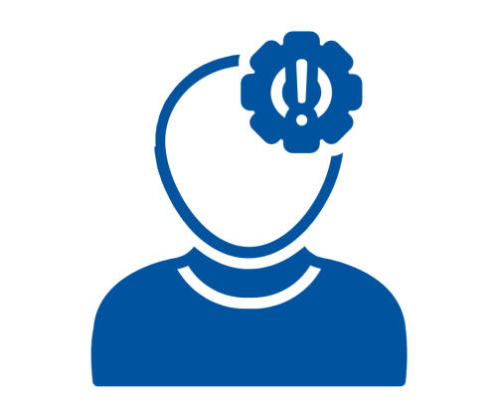
Situation: Someone tells you “I slipped and sprained my wrist.”
1) Identification: “I broke my arm once and it really hurt.”
2) Sympathy: “That must have hurt. I guess you couldn’t take your exams.”
3) Lack of sympathy: “Perhaps you needed to be more careful.”
4) Empathy: “How did that feel? How is it affecting you now?”

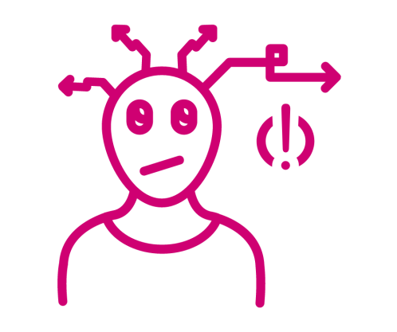
Situation: A student tells you “I failed my end-of-term exams
- Identification: “Oh dear, I failed all mine.”

- Sympathy: “Oh, how terrible for you!”
3) Lack of sympathy: “Perhaps you didn’t study enough.”
4) Empathy: “I guess that feels disappointing for you, what are your plans now?”

Situation: A student tells you “I feel horrible today.”
- Identification: “I know me too I think it’s the weather.”
- Sympathy: “Oh dear what a shame.”
- Lack of Sympathy: “You haven’t been looking after yourself.”
- Empathy: “That sounds like a hard day. What has been going on for you?”

Active Listening, A Further Look
Think about what you would put in your ‘Room 101’. Think about how easy it is to become annoyed/contain your emotions on something you feel strongly about.
Remember that feeling of feeling so frustrated, agitated or just generally annoyed? That is a normal human response and reaction, however, it is far too easy to pass judgement or let our emotions weigh in when we are having discussions with other people.
Active listening involves several different techniques but the absolute baseline of this is being non-judgemental. Putting your emotions aside to hear and understand the experiences of the young person in front of you.
Thinking about what these other four elements look like in a conversation…
Listen to hear not respond: not thinking about what you will say in return, taking the time to hear the other person and not putting your own assumptions into their experiences. While relating to them with your lived experience is validating, it can take away THEIR truth, or have you avoid hearing entirely their point of view. And thinking of a ‘fix’ response is also keeping you away from listening.
Attentive + attuned: give them your attention, try not to be working on other things or rushing them off. Be attuned to their emotions and your own, try and use open body language and supportive words. Remember this idea of maintaining open curiosity ‘and what else’ for non-verbal language.
Open questions / clarify: try and ask open-ended questions (as we have given empathetic suggestions for) so the young person has an opportunity to speak about how they feel, but don’t probe. You need information so you have clarity on their situation, but don’t need unnecessary details.
Summarise / paraphrase: try and repeat or review what you have been told, to highlight that you are listening but also to make sure you have correct facts.

Examples of Empathetic Questions, Which Help Us Summarize and Gain Clarity
We are clarifying what we have hard, and gaining clarity on a persons situation. We are allowing people to speak about how they feel. Some of these examples might feel formal, and it’s important to practice this principle to find your own comfortable way of asking reflective and empathetic questions.
HELPFUL: Reflective Questions
Can help people understand more about what they said — for example, someone tells you, “I’m worried I won’t remember.”
A good reflective questions might be something like,
“It sounds like you would like some help remembering, or you’re concerned about your memory in the future?”
Think about using questions such as: “You mentioned you didn’t like X. What parts of it did you particularly dislike?”,
“You said the year was hard, what were some of my most challenging moments and what made them so?”
LESS HELPFUL: Leading Questions
Leading questions can sometimes be helpful, but often suggest that you know better than the person you’re talking to, or are trying to get specific information from the other person — you are leading the conversation (rather than letting them lead). You should generally avoid asking too many of these types of questions when you’re engaged in active listening. This is when it gets too close to the ‘investigation’ route that we must avoid and leave to MH Professionals or a Safeguarding Team.
For example, “Would you like to talk about it?”
“What happened then?”
“Could you tell me more?”
NOT HELPFUL: Closed-ended Questions
Close-ended questions usually can be answered with a single word. They don’t lead to more information but can make a person feel more defensive (as though the conversation is more of an interrogation than a give-and-take). Avoid these questions. Use close-ended questions to prompt for specifics — for example, lead with: “Is? Are? Do? Did? Can? Could? Would?” For example, “Would you like an apple?”
Looking After Yourself When Having Challenging Conversations
Having conversations with others about their mental health can be extremely difficult. If you are at work, it is important to ensure that you are discussing these with the relevant channels and appropriately sharing information. Look after yourself and remember to support yourself so you can best support others.
If you are practising all of the above principles do know that you are putting in a lot of mental work, whether that’s conscious or subconscious. When we say ‘be kind to yourself’ after a mental health conversation we really mean it – remember to be gentle and forgiving to yourself after putting in this immense work. Remember that by practising these principles you are playing your part and contributing to a chain of support which needs to happen around the person. Try to never feel alone with this work and reach out if you need to.

